**Use case diagram**

Application : e-nursery (web application)

Actors in system : admin , customer, farmer

Front end : html , CSS , JS , Bootstrap

Backend : python with Django framework (4.2.5)

Database : sqlite3

Admin:

* can manage users in system and all database and backend related work
* can also register login

Farmer:

* Farmer can registration, login, get otp in mail or SMS, create /change password.
* Famer can add product , manage product, update, delete them from the system.
* can also get reviews on specific product from customer.

Customer:

* Customer can registration , login , get Otp in mail or SMS , create password.
* Can visit website also can view all products from different farmers and also review on particular products.

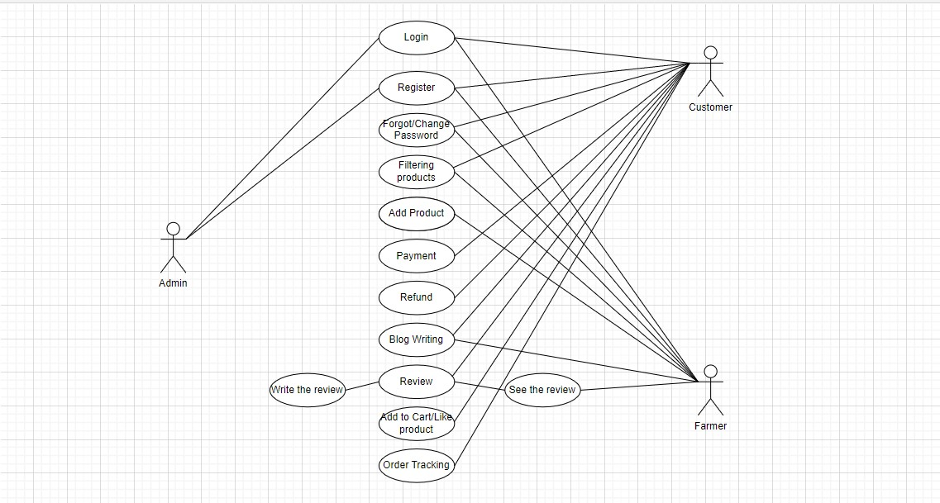

**Fig. use case Diagram**